**My Perception about ICT Ma Deuce PDAs:** Ma Deuce is a type of IFVG, used by large institutions to help them detect the next DOL.

$NQ:

1. In weekly-chart, which is HTF chart, ERL taken.
2. The next expected DOL is IRL, which is daily BISI.
3. Until Wednesday half of the price job done.
4. In one-minute chart price consolidate in the orange shade area.
5. Now it is time for forecasting whether Price wants to go up or go down using economic news release
6. When HTF DOL is big. Define it in this manner: 0, 0.125, 0.25, 0.375, 0.5, 0.625, 0.75, 0.875, 1

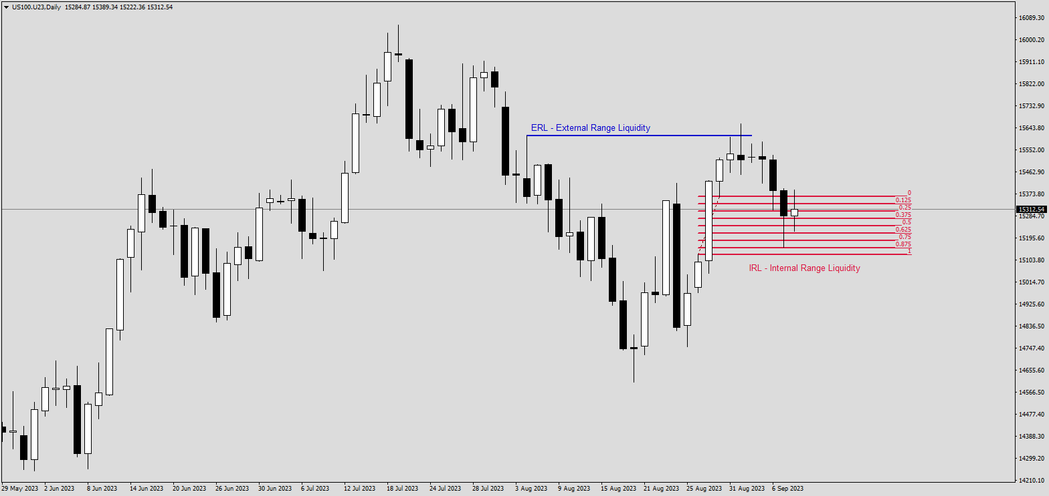

Ma Deuce:

1. Price reaches to the middle (**$$$**) of DISCOUNT HTF key level
2. It takes more time (**$$$**) than other PDAs, because it might be the HTF turning point (in this case it takes 4 hours).
3. Short-term Bullish FVG above Short-term bullish OTE.
4. Price see that as inefficiency.
5. Wait for price to fill this inefficiency with both SSD and BSD.
6. If the Next Price Swing closed above it, the bias is bullish.
7. If the Next Price Swing closed below it, the bias is bearish.

